Image | 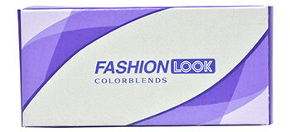
Brand | DIOR
Model Name | FASHION LOOK
Price | RS 2650
PRODUCT DETAILS

